BIOC 455
Lecture #12 – Neurotransmitter Release
Lecturer: Dr. Sylvain Williams – January 31st, 2007

NOTE: This NTC is meant to be used as a study aid to supplement your own class notes. Hence, not all of the text or diagrams contained in the lecture slides will be reproduced here.

Please send any comments or questions about NTCs to either Wanda or James through e-mail at u3.represent@gmail.com .

Continue from last class:
- There are some proteins involved in neurotransmission.

- Sequence of Neurotransmission:
Action potential → Ca²⁺ ion influx → Vesicles travel to the axon terminal and bind to terminal membrane → Neurotransmitter released to synaptic cleft → Neurotransmitters bind to post-synaptic receptors.
Two big families are ionotropic receptors and metabotropic receptors:
For glutamate, AMPA and NMDA are the two most important ionotropic receptors which open the Na⁺ channel upon being activated.
For GABA, the major receptor is GABAa receptor which opens the Cl⁻ channel when activated. The metabotropic receptors will activate second messengers like G-protein or kinases.

- GAP-Junctions and Electrical Synapses involve the protein called connexin which located both pre- and post-synaptically. Though only a few of them are in the brain, but play very important role. By gap junctions, ions can flow directly from pre-synaptic to post-synaptic. This action is extremely quick (0.1ms). Some diseases are caused by dysfunction of electrical synapse. Epilepsy is one of them.

Neurotransmitter Release
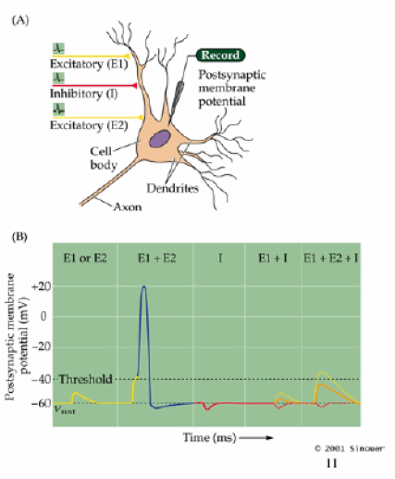
- Summation of Postsynatpic potentals: neurons can integrate excitory and inhibitory postsynaptic potentials temporally and spatially. Only the summation of EPSPs and IPSPs is higher than the threshold can depolarize the cell.

- Voltage-gated sodium channels are not very important in neurotransmitter release. In the experiment, TTX-an antagonist for sodium ion channels, is injected into the neuron to block the ion channels. As increase of the depolarization of the presynaptic neuron by input current, increase of post-synaptic depolarization is observed. It showed that voltage-gated sodium channel at the axon terminal is not important for release of neurotransmitters.

- The same experiment showed that potassium channels are not important for neurotransmitter release.
- Calcium ion and voltage-gated Calcium channels are critical involved in NT. This is showed by decrease the concentration of sodium ions and eventually neurotransmitter release is blocked. The experiments also show the amount of Calcium entered the pre-synaptic neuron is directly related to the size of the post-synaptic potential.

- The time sequence of NT release: Pre-synaptic potential → pre-synaptic Ca inward current → post-synaptic potential

- Presynaptic calcium channels can be blocked by natural compounds. N-type is the most important. Ca channels which can be blocked by ω-conotoxin. By blocking the ion channels, this antagonist can block the neurotransmission. Another blocker for P/Q Ca²⁺ channels is ω-agatoxin from spider venom.
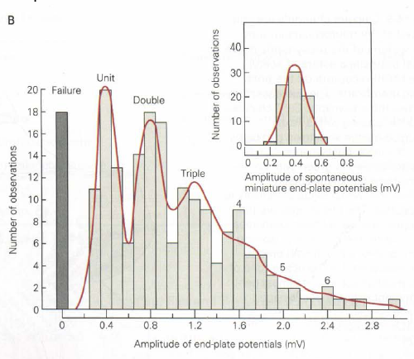
- Quantal nature of post-synaptic potential. The experiment was done on the neuro-muscular junction. The recording of the post-synaptic potential indicates that the size of the potential is always a multiple of a single event (about 0.4mV). The single event is caused by one release vesicle packing 5000NT.

- Using freeze-fracture technique to observe the pre-synaptic vesicle fusion with the membrane. These vesicles are attached together by certain protein at the active zone. The active zone is thought to be close to the calcium channels.
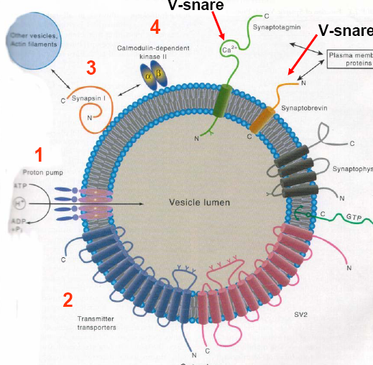
- Proteins found on vesicles.

–Proton pump: important for transmitter transporters.
--Transporter: transport the NT into the vesicle.
--Synapsin: can bind to actin filament and further linked to other vesicles at the presynatpic terminal. Upon calcium enter the versicle, it activates the calcium calmodulin kinase II which phosphorylate synapsin. The phosphorylated synapsin then can be released from the vesicle cluster and ready for fusion.
--Synaptotagmin: A calcium sensor that can bind the calcium ion and trigger the vesicle fusion. Knockout of this gene will impair the vesicle fusion. Its conformational change facilitates the snare complex formation.
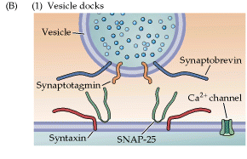
--Synaptobrevin: important for binding with other proteins at the pre-synaptic terminal. It forms snare complex with syntaxin and SNAP-25
--Synaptophyxin is not important.

